# PRACTICAL - 2 (2.1)

**AIM:** Design an application representing a simple calculator.

**DESIGN:**

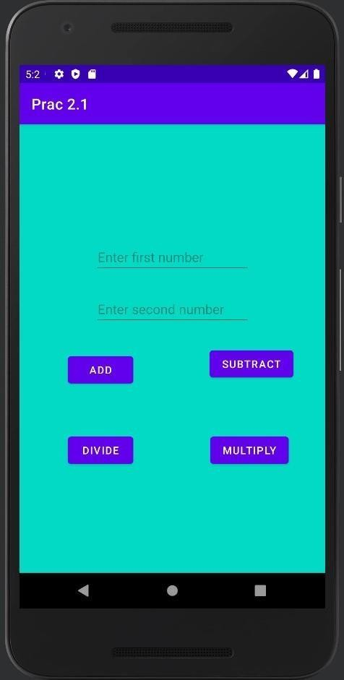

**CODE:**

package com.example.prac21;

import androidx.appcompat.app.AppCompatActivity; import androidx.constraintlayout.widget.ConstraintLayout;

import android.os.Bundle; import android.view.View; import

android.widget.Button; import android.widget.EditText; import android.widget.Toast;

public class MainActivity extends AppCompatActivity { EditText et1, et2;

Button add, sub, mul ,div; ConstraintLayout cl;

@Override

protected void onCreate(Bundle savedInstanceState) { super.onCreate(savedInstanceState); setContentView(R.layout.activity_main);

add = findViewById(R.id.add);

sub = findViewById(R.id.subtract); mul = findViewById(R.id.multiply); div = findViewById(R.id.divide); et1 = findViewById(R.id.getNum1); et2 = findViewById(R.id.getNum2); cl = findViewById(R.id.cons);

cl.setBackgroundColor(getResources().getColor(R.color.teal_200)); add.setOnClickListener(new View.OnClickListener() {

@Override

public void onClick(View v) {

int a = Integer.parseInt(et1.getText().toString()); int b = Integer.parseInt(et2.getText().toString()); int z = a+b;

Toast.makeText(MainActivity.this, Integer.toString(z),Toast.LENGTH_SHORT).show();

}

});

sub.setOnClickListener(new View.OnClickListener() { @Override

public void onClick(View v) {

int a = Integer.parseInt(et1.getText().toString()); int b = Integer.parseInt(et2.getText().toString()); int z = a-b;

Toast.makeText(MainActivity.this, Integer.toString(z),Toast.LENGTH_SHORT).show();

}

});

mul.setOnClickListener(new View.OnClickListener() {

@Override

public void onClick(View v) {

int a = Integer.parseInt(et1.getText().toString());

int b = Integer.parseInt(et2.getText().toString()); int z = a*b;

Toast.makeText(MainActivity.this, Integer.toString(z),Toast.LENGTH_SHORT).show();

}

});

div.setOnClickListener(new View.OnClickListener() { @Override

public void onClick(View v) {

float a = Float.parseFloat(et1.getText().toString()); float b = Float.parseFloat(et2.getText().toString()); float z = a/b;

Toast.makeText(MainActivity.this, Float.toString(z), Toast.LENGTH_SHORT).show();

}

});

}

}

## OUTPUT:

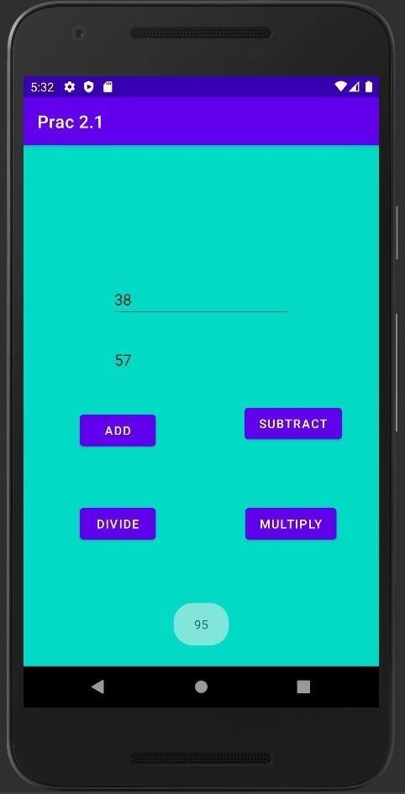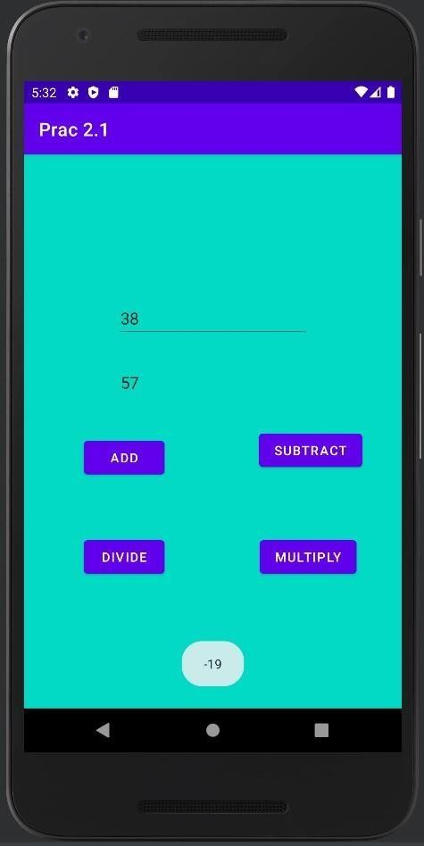

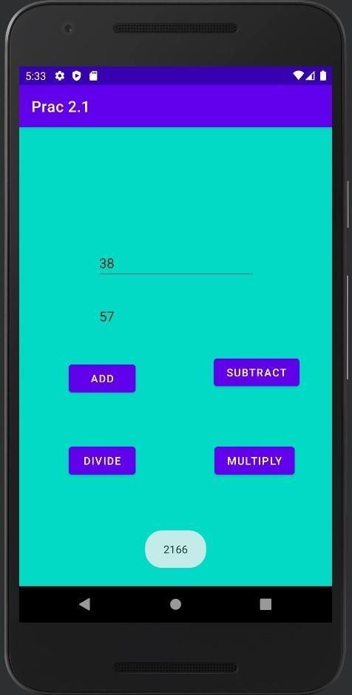

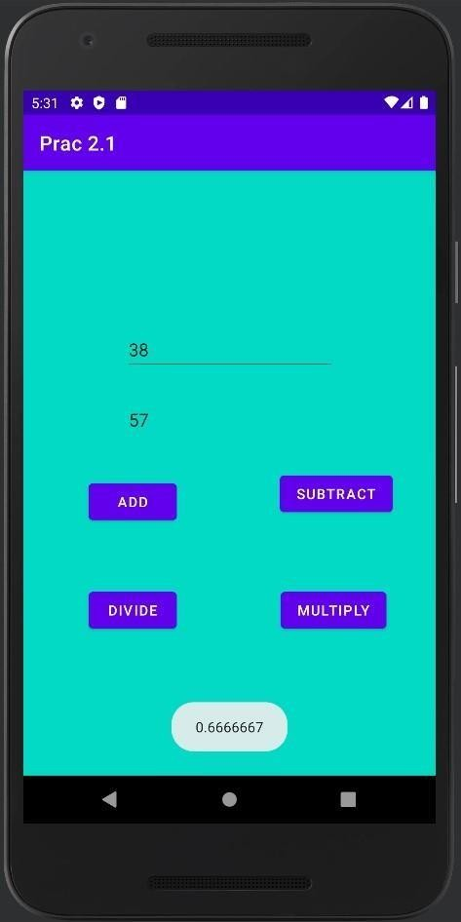

## CONCLUSION:

In this practical, we learnt about how to use multiple buttons in our activity. We also came across new terms like setOnClickListener and how to display messages on click of the button using Toast.

# 2.2)

**AIM:** Create a login application with following features:

1. Successful Login message in TextView with Green background if Username & password is correct.
2. Failure message in TextView with Red background if Username or password is incorrect.
3. Disable Login Button after three wrong login attempts.
4. Close application if user selects Cancel Button.

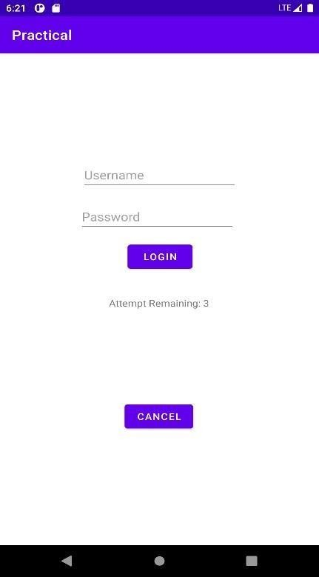**DESIGN:**

**CODE:**

package com.example.login;

import androidx.appcompat.app.AppCompatActivity;

import android.os.Bundle; import android.view.View;

import android.widget.Button;

import android.widget.EditText; import android.widget.TextView;

import org.w3c.dom.Text;

public class MainActivity extends AppCompatActivity { EditText et1,et2;

Button btn, btn2; TextView tv, tv1; int cnt=3; @Override

protected void onCreate(Bundle savedInstanceState) { super.onCreate(savedInstanceState); setContentView(R.layout.activity_main);

btn = findViewById(R.id.button); btn2 = findViewById(R.id.button2);

et1 = findViewById(R.id.editTextTextPersonName); et2 =findViewById(R.id.editTextTextPassword);

tv = findViewById(R.id.textView); tv1 = findViewById(R.id.textView2);

btn.setOnClickListener(new View.OnClickListener() { @Override

public void onClick(View v)

{

if (et1.getText().toString().equals("yatharth")&& et2.getText().toString().equals("admin"))

{

tv.setText(" Logged in Successfully "); tv.setBackgroundColor(getResources().getColor(R.color.purple_500)); tv1.setText("");

cnt = 3;

}

else{

tv.setText(" Invalid Username/Password "); tv.setBackgroundColor(getResources().getColor(R.color.teal_700));

cnt--; if(cnt==0){

btn.setEnabled(false);

}

tv1.setText(" Attempts Remaining: "+cnt);

}

}

});

btn2.setOnClickListener(new View.OnClickListener() { public void onClick(View view) {

finish(); } });

}}

## OUTPUT:

* 1. On successful login:

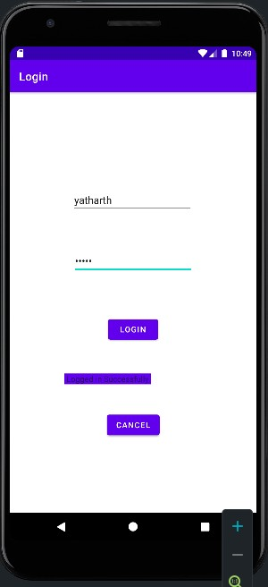

* 1. On wrong attempt:

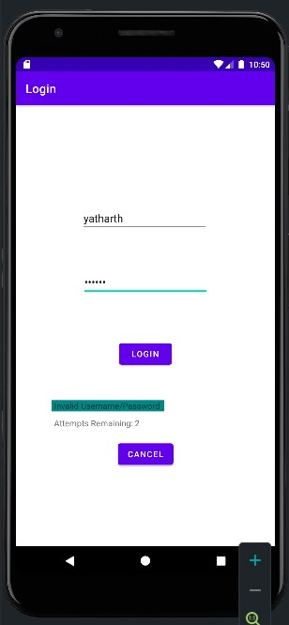

* 1. On 3 wrong attempts:

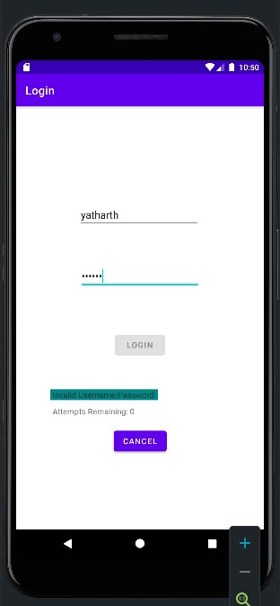

* 1. By clicking on the terminate button, the user will return to the home screen.

## CONCLUSION:

In this practical, we learnt about how we can change the background color of the textView according to the conditions. We also learnt how we can disable a button using the setEnabled() method. We also learned how to terminate the whole application by just using a simple function known as finish().

# 2.3)

**AIM:** Create android application to demonstrate life cycle of activity.

**DESIGN:**

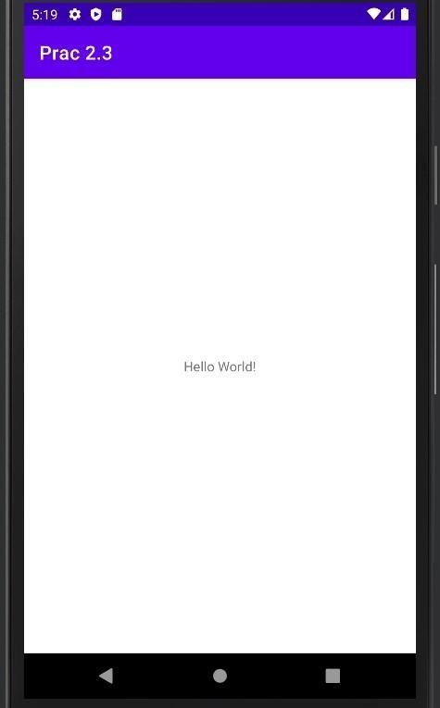

**CODE:**

package com.example.prac23;

import androidx.appcompat.app.AppCompatActivity; import android.os.Bundle; import

android.util.Log;

public class MainActivity extends AppCompatActivity { private static final String tagname="20DCE019"; protected void onCreate(Bundle savedInstanceState) { super.onCreate(savedInstanceState); setContentView(R.layout.activity_main); Log.i(tagname,"Create method initiated");

}

@Override protected void onStart() { super.onStart();

Log.i(tagname,"Activity in the Start mode");

}

protected void onRestart() { super.onRestart();

Log.i(tagname,"Restarted the activity");

}

protected void onDestroy() { super.onDestroy();

Log.i(tagname,"Activity Destroyed");

}

protected void onResume() { super.onResume();

Log.i(tagname,"Activity Resumed");

}

@Override protected void onStop() { super.onStop();

Log.i(tagname,"Stopped the activity");

} }

s



## CONCLUSION:

In this practical, we learnt about Activity Life Cycle & how an activity enters into different stages according to the user's actions. The activity enters into the Create mode as soon as you run/start the project, and it directly enters into Start & Resume state. Once the activity is minimized, it enters into the Stop state. If it is opened again, the activity is Restarted, Started and Resumed. Once you go back and close the activity, the activity Stops and is Destroyed the very next moment.